Using Simulation to compare powers of different tests.

( Determining location of paired data)

**Carrying out a sign test**

H0: mx=my. H1:mx≠my

>x=c( 26.1, 26.6, 27.4 ,27.5, 27.8 ,28.1, 28.4, 29.5, 29.8 ,30.4,30.4 ,31.2 ,31.5, 32.9 ,33.6 ,34.1 ,35.9)

> y =c(27.4, 28.1, 22.9 ,31.3 ,16.3 ,50.1, 20.0 ,24.6 ,23.3, 19.3,24.4, 24.4 ,29.5, 27.6 ,21.7 ,25.4 ,39.4)

>dif=x-y

> binom.test(length(which(sign(dif)==-1)), length(dif))

Exact binomial test

data: length(which(sign(dif) == -1)) and length(dif)

number of successes = 5,

number of trials = 17,

p-value = 0.1435

alternative hypothesis: true probability of success is not equal to 0.5

95 percent confidence interval:

0.1031355 0.5595827

sample estimates:

probability of success

0.2941176

**Pvalue is greater than 0.05, thus we do not have sufficient evidence to reject the null: mx=my.**

**Carrying out a Wilcoxon test**

H0: mx=my. H1:mx≠my

> dif=x-y

> wilcox.test(dif)

Wilcoxon signed rank test

data: dif

V = 124, p-value = 0.02322

alternative hypothesis: true location is not equal to 0

**p-value is less than 0.05, thus we reject the null hypothesis IE my ≠ mx**

**Carrying out a T test**

Assuming a normal approximation for the data, we know that mx=mux, thus, H0: mux=muy. H1:mux≠muy

> t.test(x,y, paired = TRUE)

Paired t-test

data: x and y

t = 1.6402, df = 16, p-value

= 0.1205

alternative hypothesis: true difference in means is not equal to 0

95 percent confidence interval:

-0.954790 7.484202

sample estimates:

mean of the differences

3.264706

**We do not have sufficient evidence to reject H0. IE mx=my.**

**Comparing the different tests.**

The Wilcoxon test gives a different conclusion as compared to the t.test and the sign test. From the quick diagnosis below, we can see that the assumption made for the t.test is not a good assumption IE the data does not really fit a normal distribution. The symmetry assumption for the Wilcoxon test is a poor one too, as seen by the the negative skew value of -1.736865 below. Thus the sign test’s conclusion’s is what we use, IE, we do not have sufficient evidence to reject the null hypothesis.

>qqnorm(x)

> qqline(x)

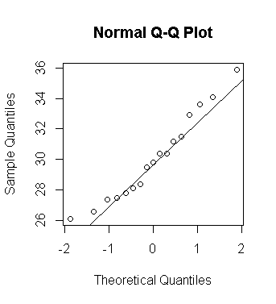

> qqnorm(y)

> qqline(y)

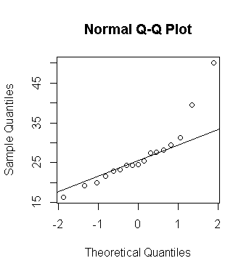

> skewness(dif)

[1] -1.736865

**Comparing the test using simulation and power.**

>B=1000

>n=25

> pvals.t=replicate(B,t.test(rnorm(n,3,sd=5))$p.value)

> pvals.w <- replicate(B, wilcox.test(rnorm(n,3,sd=5), exact=FALSE)$p.value)

> pvals.s= replicate(B,binom.test(length(which(sign(rnorm(n,3,sd=5))==-1)),length(sign(rnorm(n,3,sd=5))), alternative = "two.sided")$p.value)

> power.t =mean(pvals.t<0.05)

> power.w =mean(pvals.w<0.05)

> power.s =mean(pvals.s<0.05)

>

> power.t

[1] 0.815

> power.s

[1] 0.617

> power.w

[1] 0.802

Given that H0 is false and the t test has the highest power, we conclude that it is the better test.